# Hybrid Exercise 1

**Exercise 1:**

Note: This utilizes the function demonstrated in Exercise 2.

**Exercise 2:**

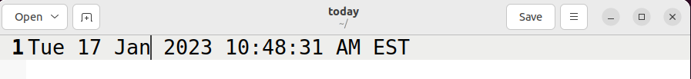

**Exercise 3:**

**Exercise 4:**

**Exercise 5:**

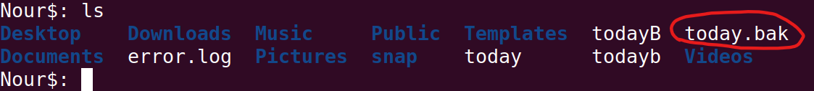

**Exercise 6:**

**Exercise 7:**

Note: Nouraldin was originally named Nour in the contents of the directory.

**Exercise 8:**



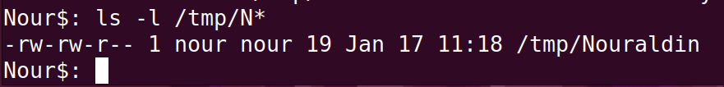

**Exercise 9:**

**Exercise 10:**

Note: cut -d: -f2 Province was used first.

**Exercise 11:**

